AIM: Sharing, Publishing, and Presenting Data Visualizations

A: Export Dashboards as PDF/Image

Sheet 1: Content Type Split (Bar Chart)
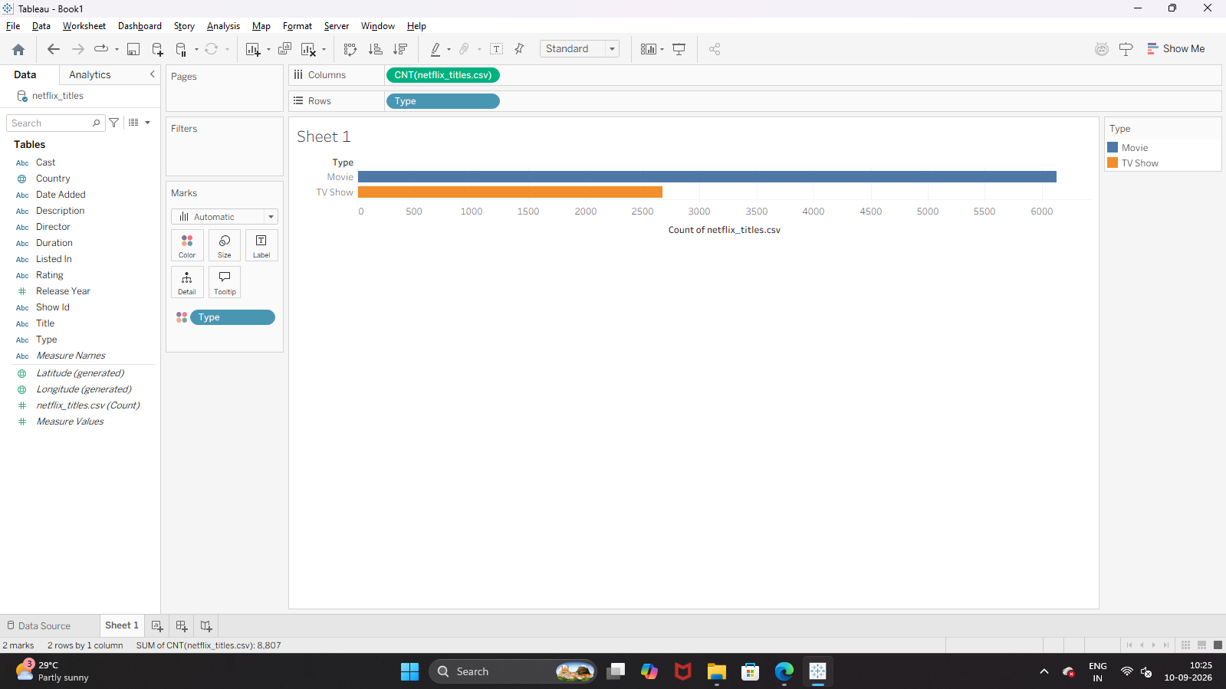
Sheet 2: Release Year Growth (Line Chart) Sheet 3: Top 10 Ratings 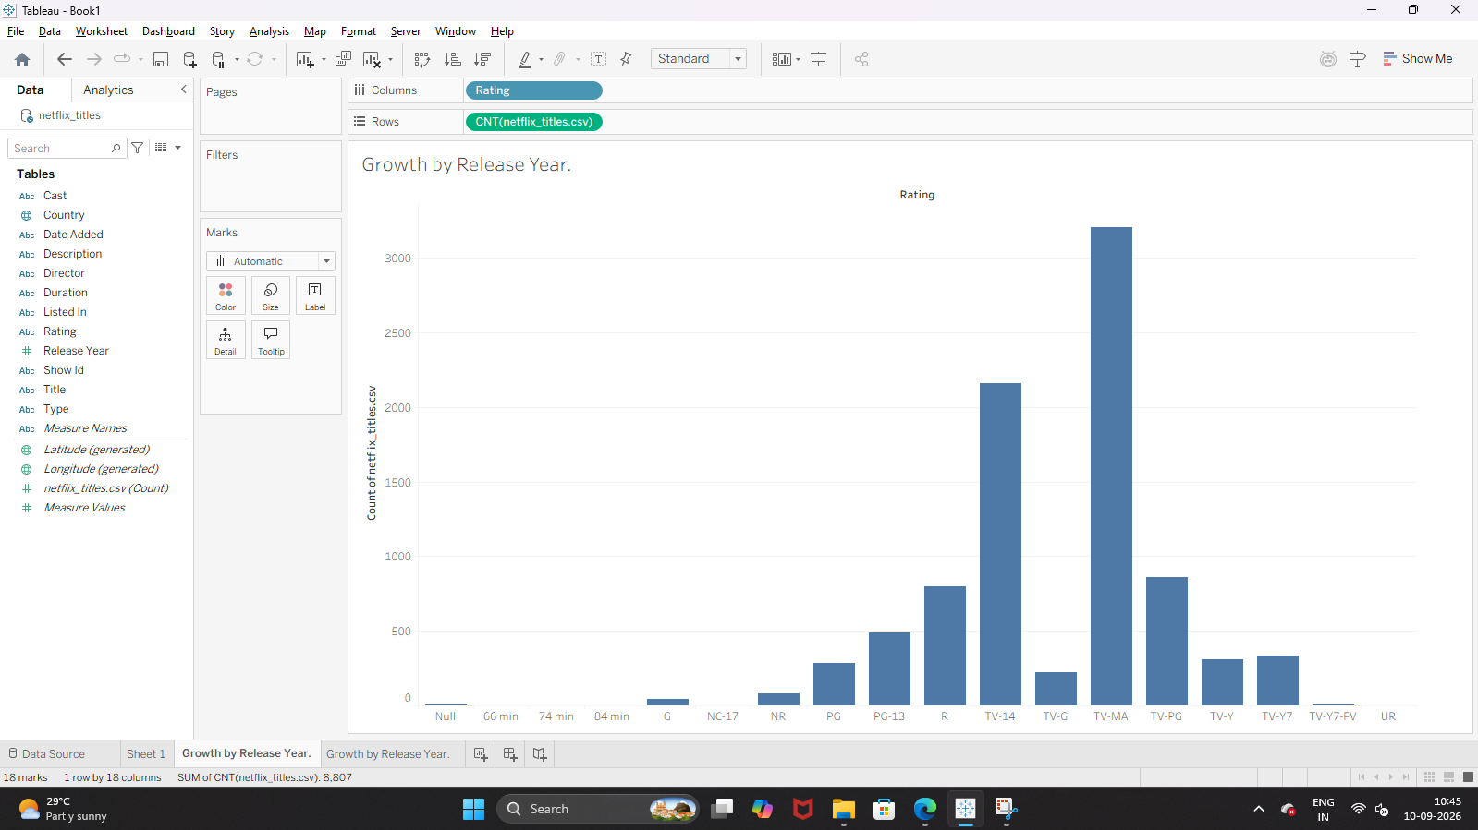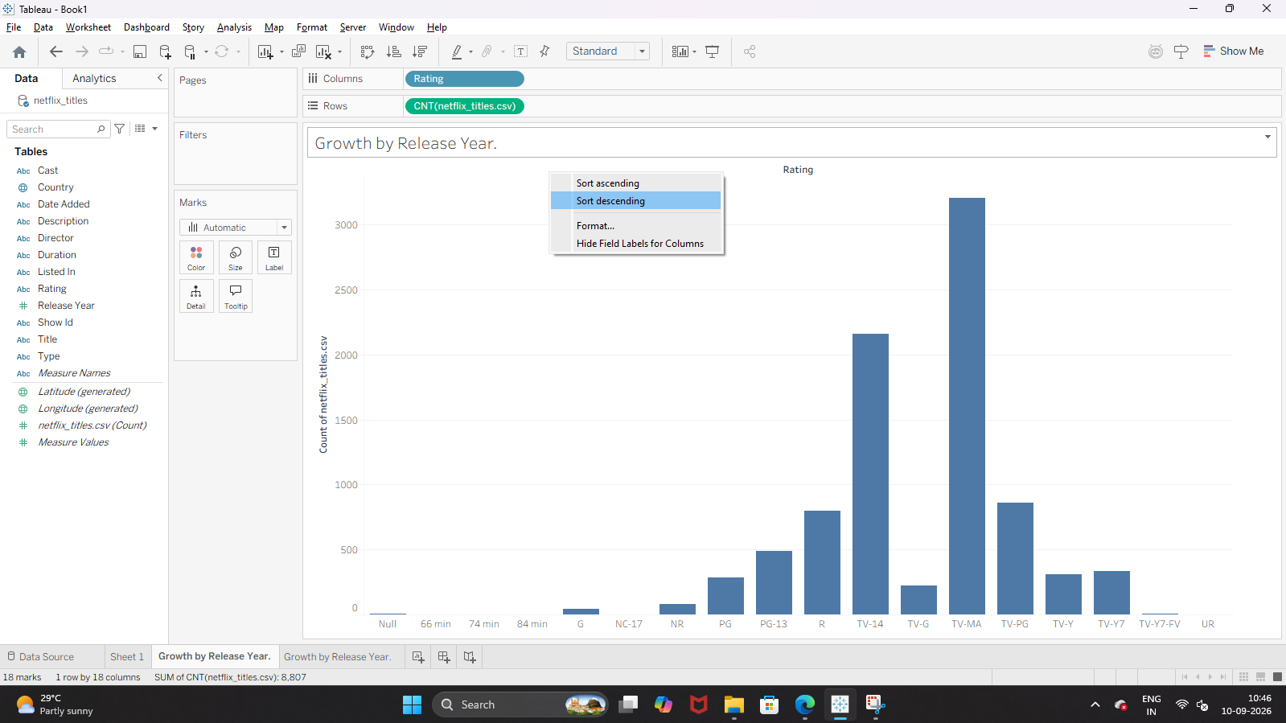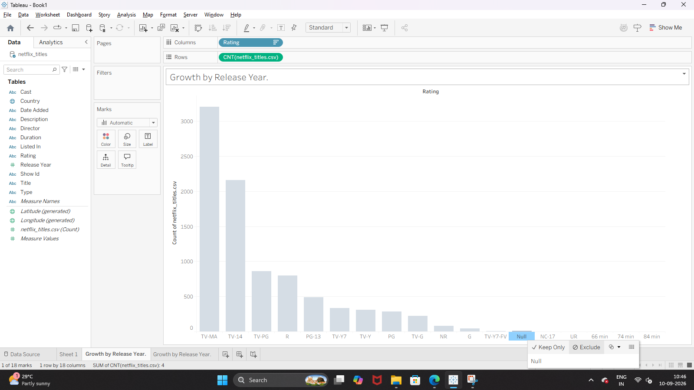
Step 2: Assemble the Executive Dashboard
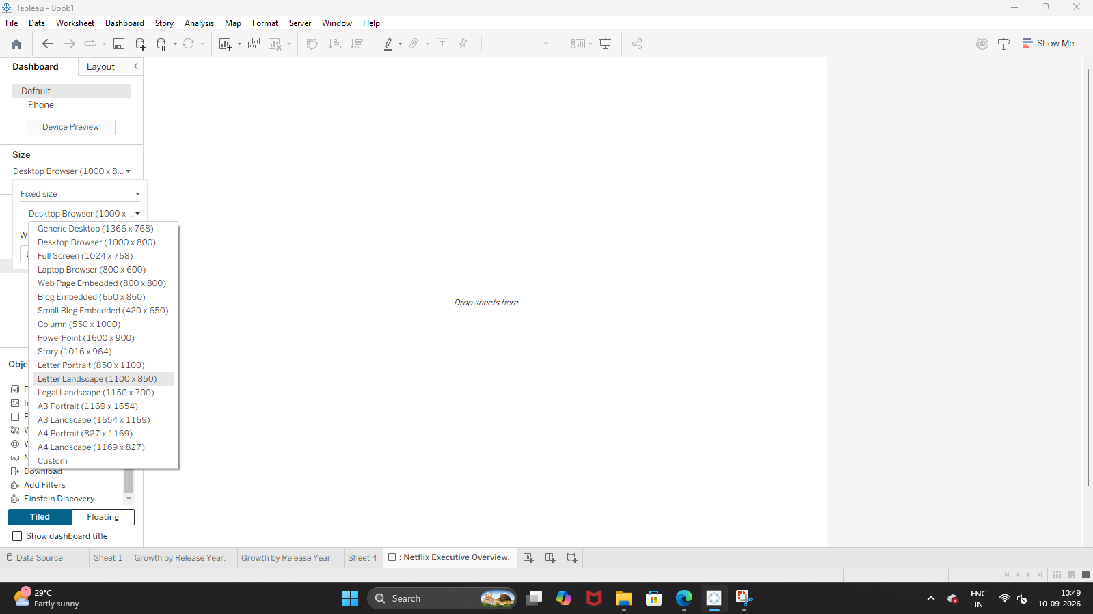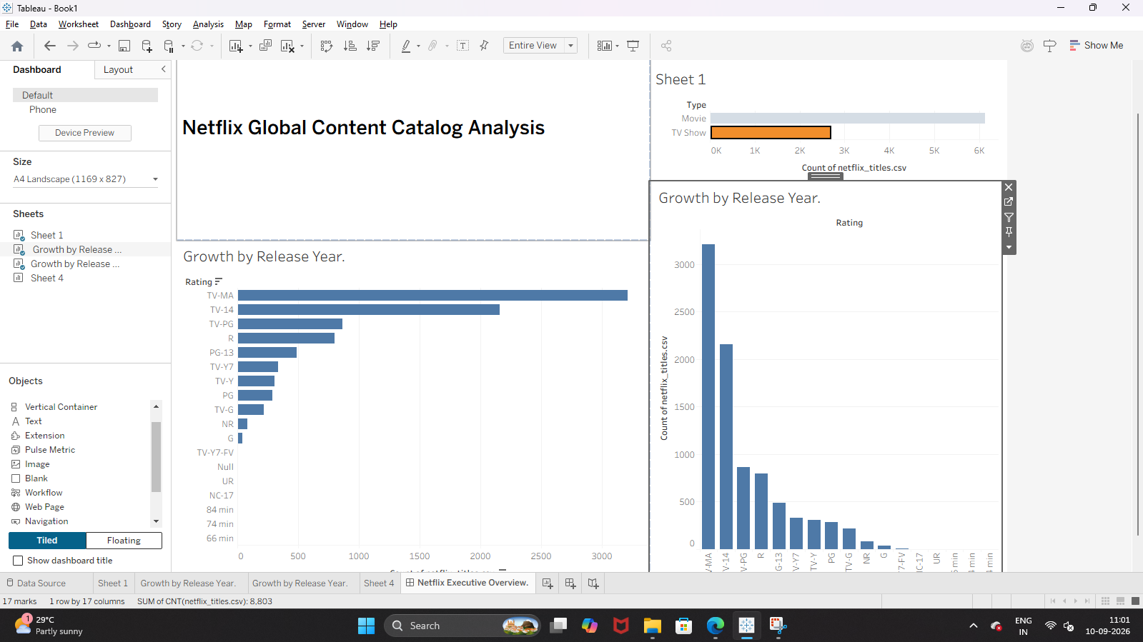Step 3: Export as High-Resolution Image (Raster / Vector)
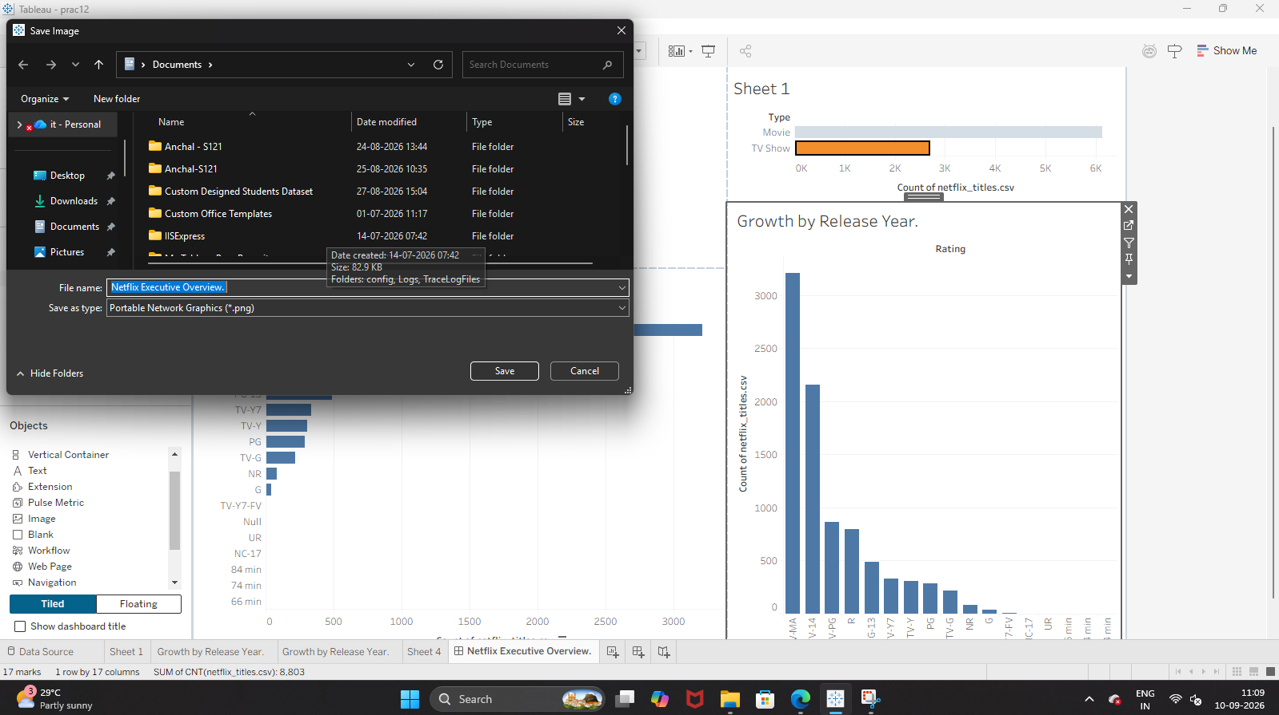Step 4: Configure Print Setup and Export to PDF 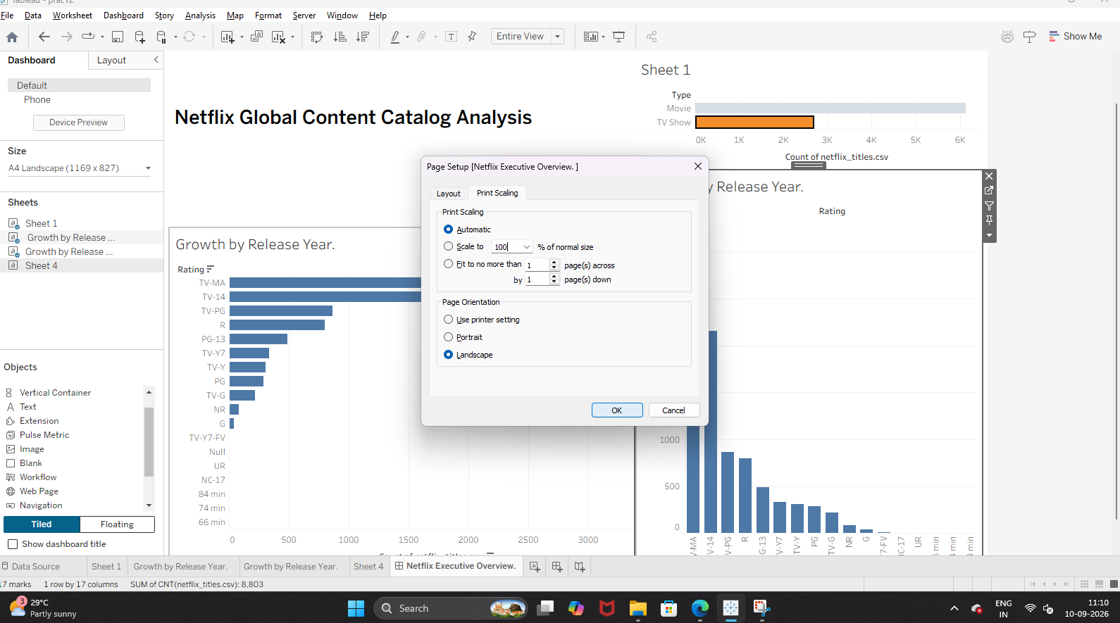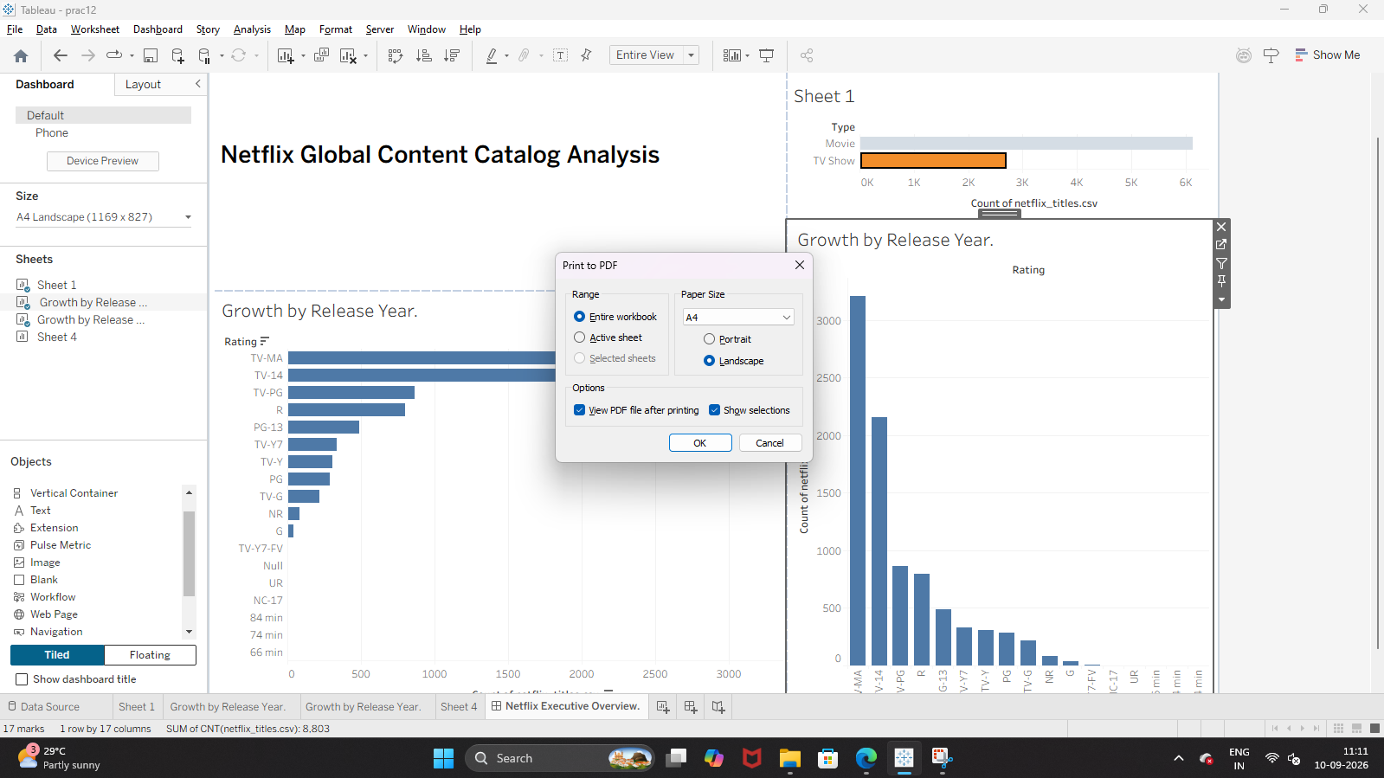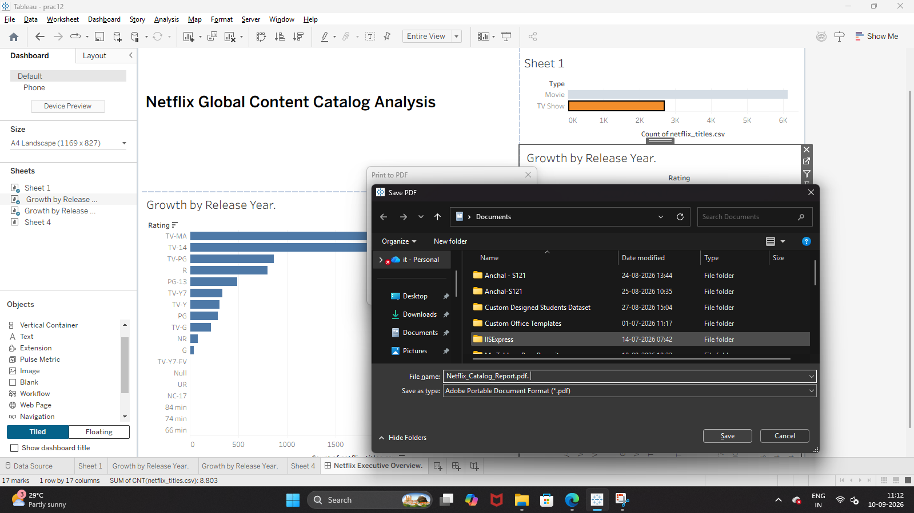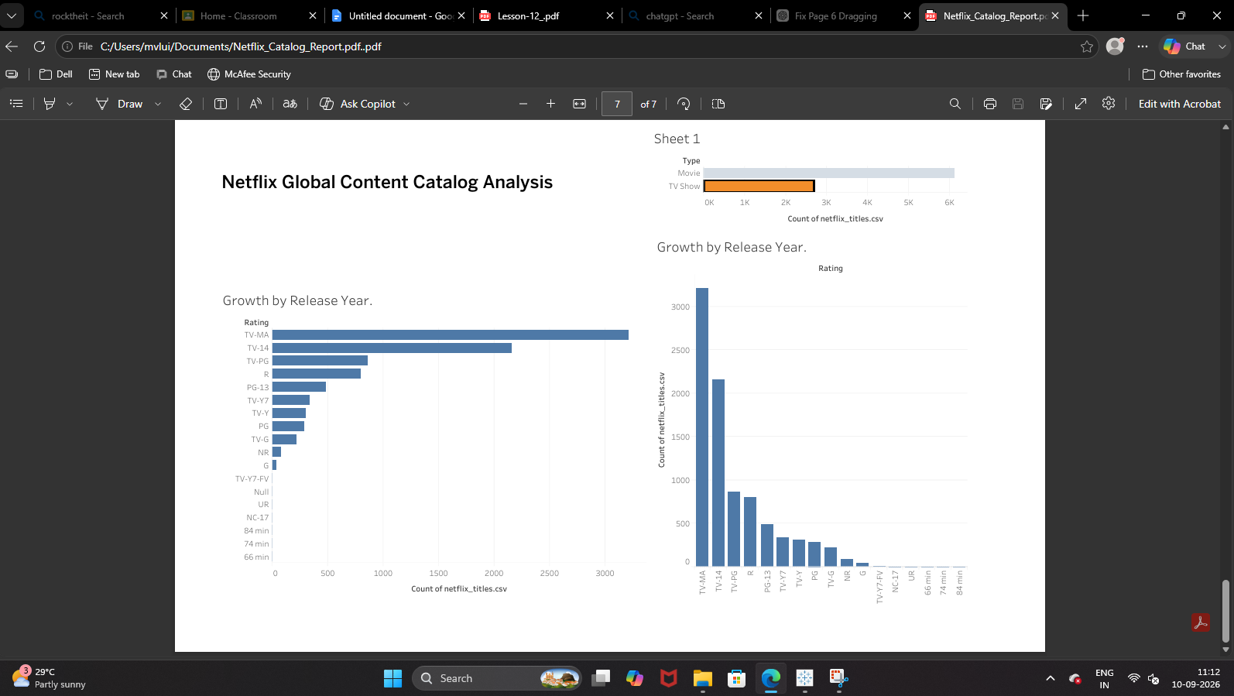B: Use Presentation Mode in Tableau

Step 1: Launch Presentation Mode
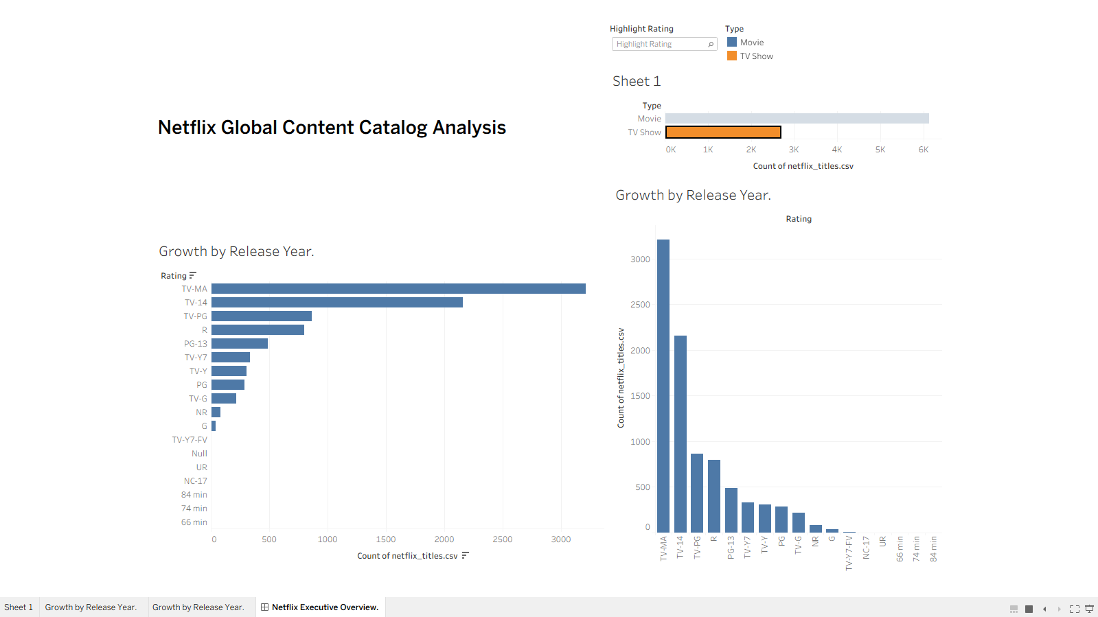C: Publish Dashboards to Tableau Public

Step 1: Confirm Data Extract Status 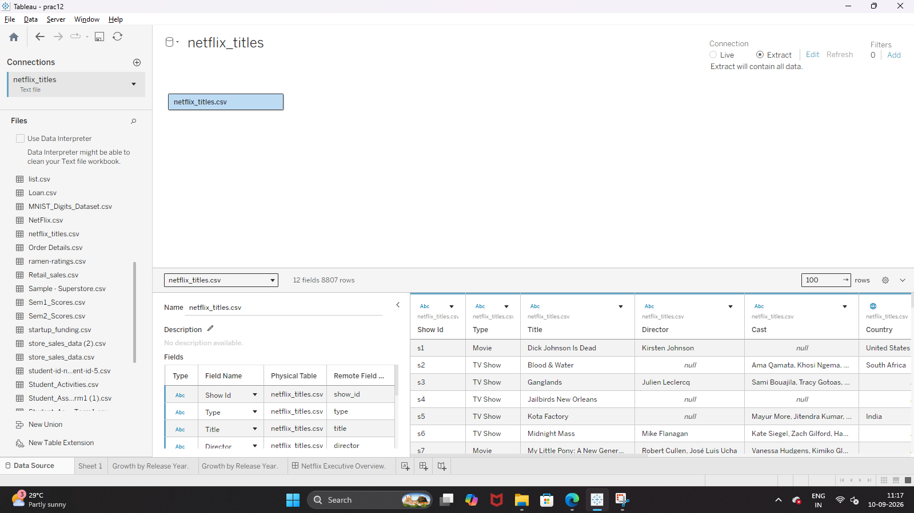Step 2: Prune Unused Columns to Minimize File Footprint 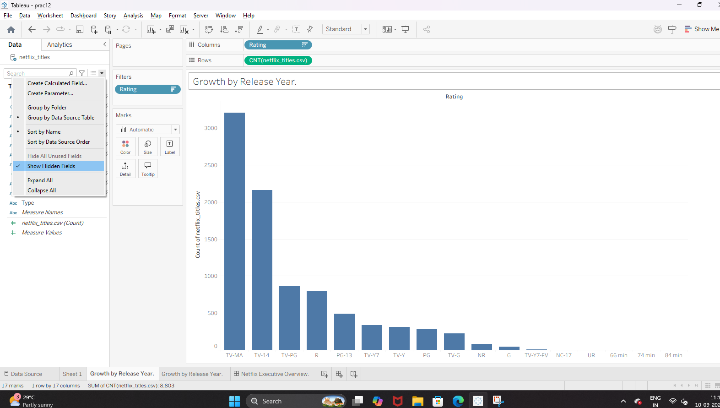Step 3: Pin the Default Landing Tab 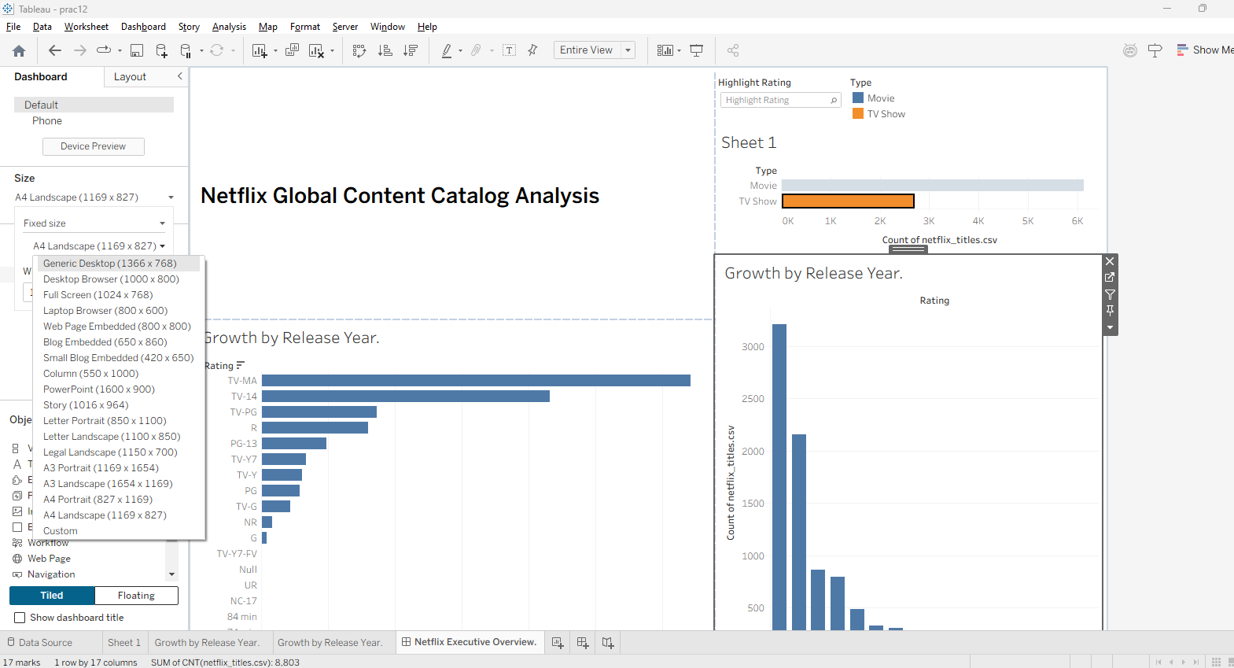Step 4: Export the Standalone Packaged Workbook (.twbx) Step 5: Verify Archive Integrity Locally 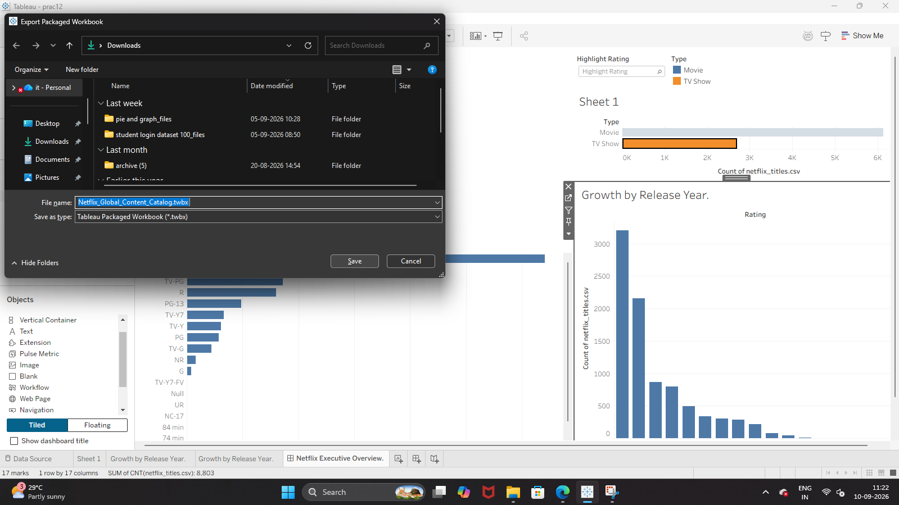 Step 5: Verify Archive Integrity Locally 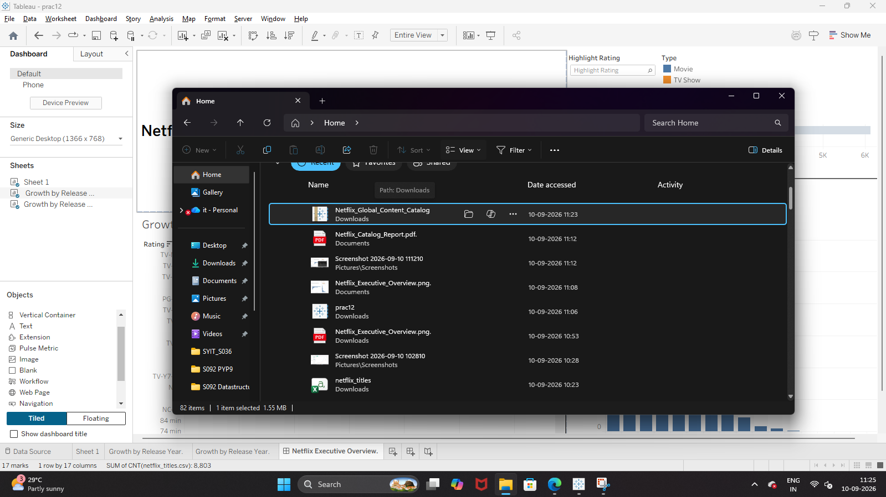Additional Step : Publish to Tableau Public via Web Interface[ if you have tableau public login]

